More white box testing
Modified condition coverage
- Reduces tests (from 2^n tests to n+1 tests)
- Tests important values (that change the outcome)
Eg. No short circuiting, below example: Any input of member_status != “premium” is not a valid test for cart_value
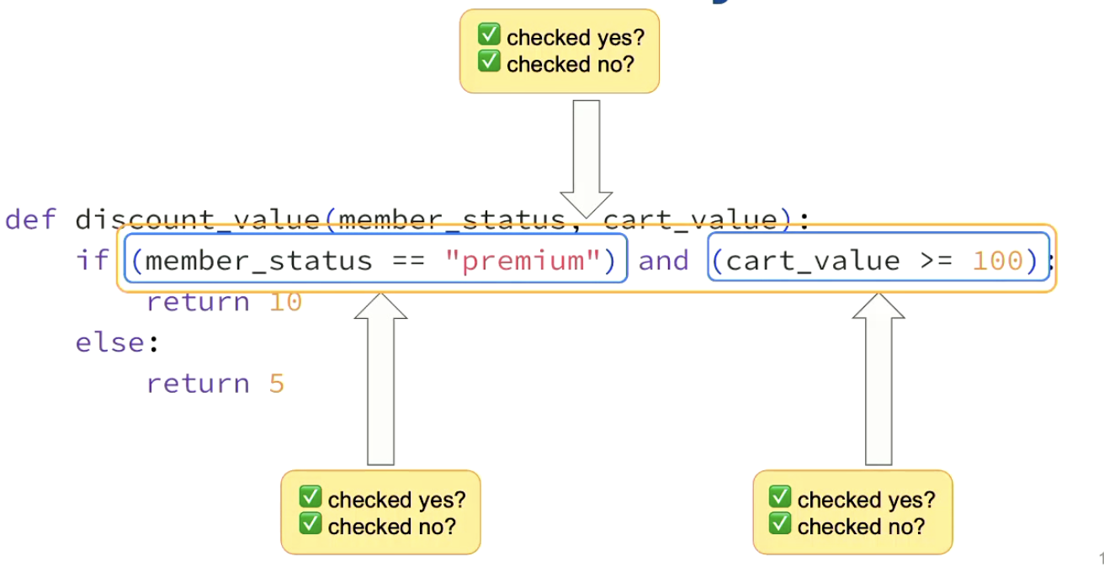
- Finding tests for (A and (B or C)) using modified condition coverage
  - Have to test 5,6,7, since B and C can only be tested with 1 independence pair each
  - A can be tested with any of the 3 independence pairs - doesn’t matter which one, but to minimise tests, we don’t test {4,8} (would mean we have to do 1 extra test compared to the other pairs)
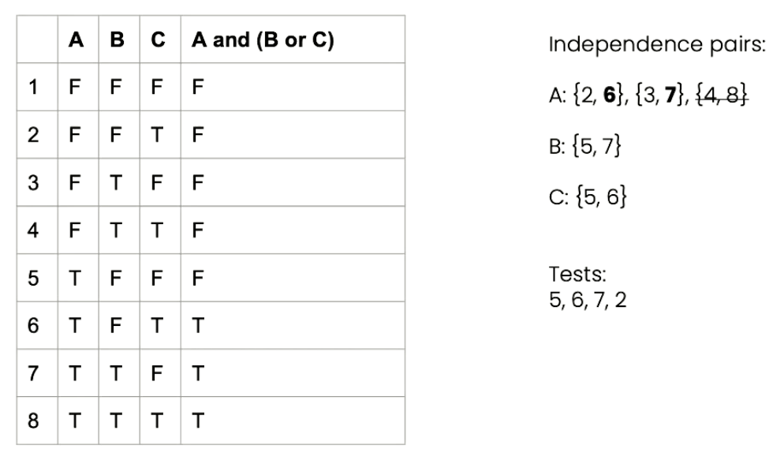
Path coverage + Control flow graph
- Shows what paths are possible
- Write 1 test per path
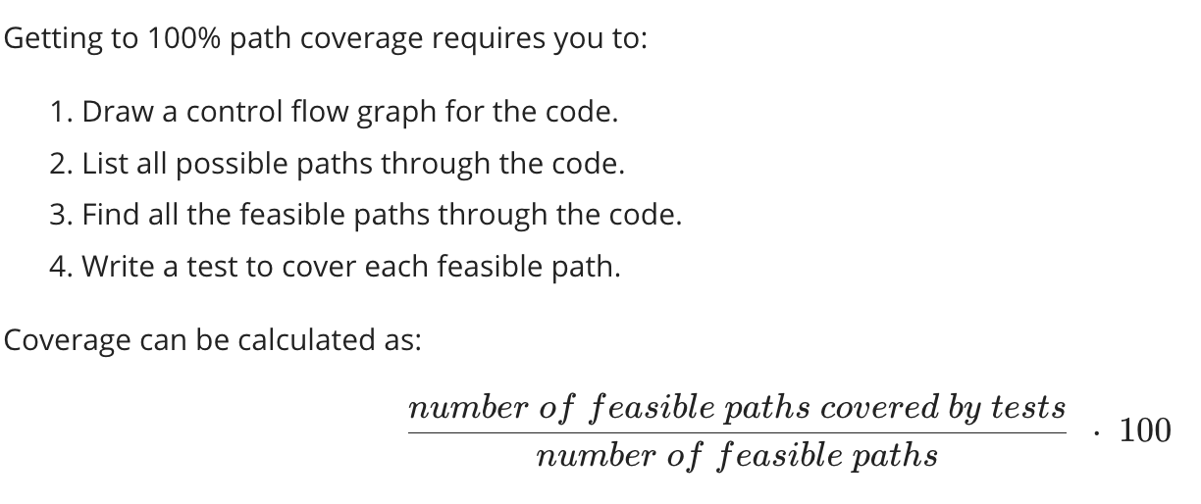
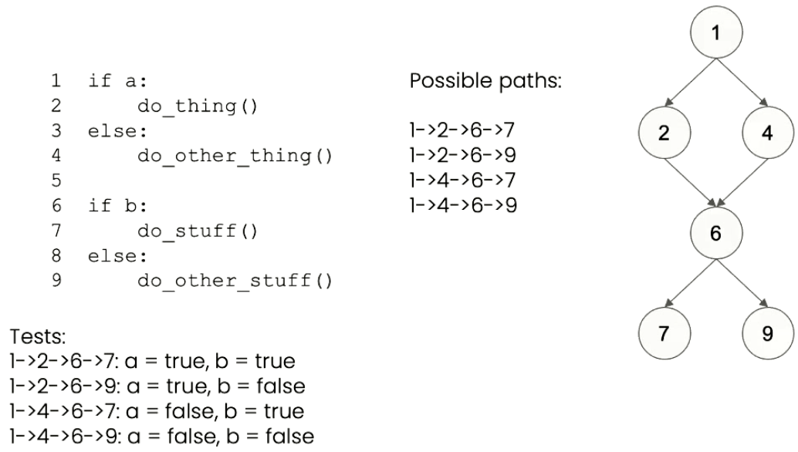

Another example:
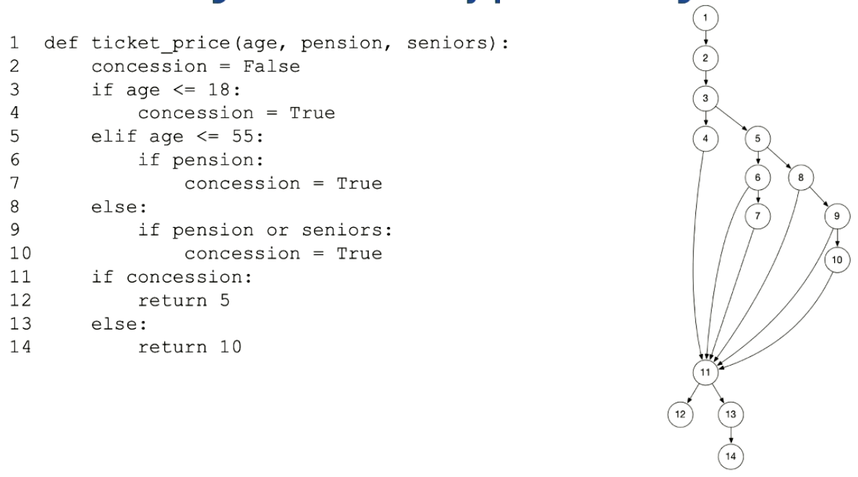
Check feasibility of each path:
Feasible path example:
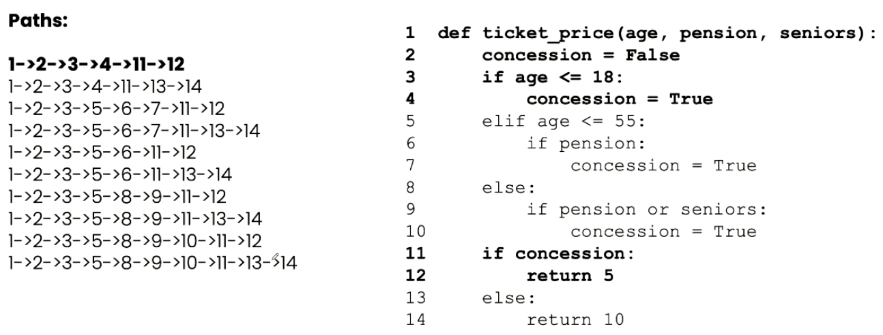
Unfeasible path example (concession changed to True, 13 & 14 can’t be reached):
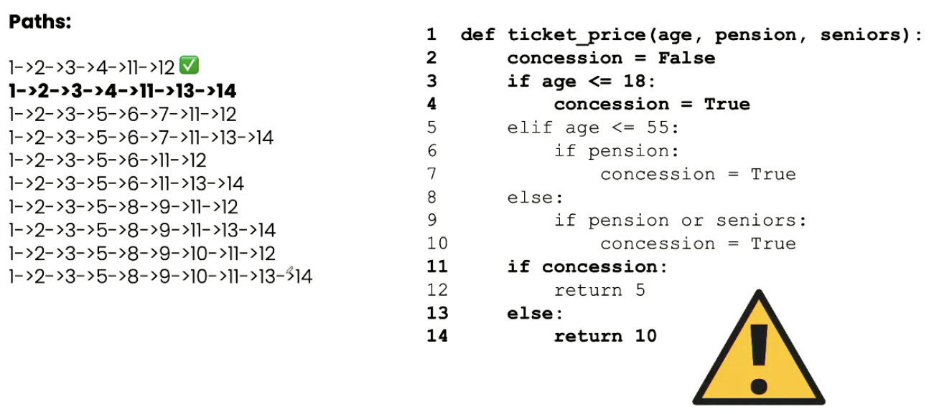
# paths through this code is 8!
- Every time you get to a decision point, you branch all the different ways through the decision point (this unit won’t need us to do all these paths tho, only yes or no)
